Purdue University

Department of Economics

**ECON 370 International Trade**

**Final Exam**

**First Name: ____________________________________________________________**

**Last Name: ____________________________________________________________**

**PUID: ___**______________________________________________________________

**DO NOT WRITE IN THE AREA BELOW:**

Section 1: _ _ _ _/30

Section 2: _ _ _ _/20

Section 3: _ _ _ _/30

Section 4: _ _ _ _/20

Total: _ _ _ _/100

**Instructions. Please read carefully.**

Write your answer in the space provided between questions. Use the blank page for scratch work.

While submitting the exam attach your cheat sheet.

Good Luck!

**Section 1. Very Short Answers**   **(30 Points)**

Multiple choice questions (28 Points)

* 1. The acquisition of the European company Jaguar and Volvo by the American company Ford Motor Company in 1989 and 1999 is an example of:

1. Horizontal FDI
2. Vertical FDI
3. Reverse Vertical FDI
4. None of the Above

Answer:

* 1. Reason for the resurgence of trade in the First golden age of trade (1890 -1913):

1. Improvement of transportation
2. Reduction of tariff
3. End of world war
4. None of the above

Answer:

* 1. A Canadian visiting the Eiffel Tower is an example of _________________________ of France and ____________ of Canada.

1. service export, service import
2. service import, service export
3. goods import, goods export
4. goods export, goods import

Answer:

In questions 1.4. and 1.5., a statement is given. You have to identify in which model the statement is valid.

* 1. L can move freely across countries.

1. Ricardo Model
2. Specific Factor Model
3. Heckscher Ohlin Model
4. None of the options

Answer:

* 1. Trade happens because there is difference in technologies across countries.

a Ricardo Model

1. Specific Factor Model
2. Heckscher Ohlin Model
3. None of the options

Answer:

Consider the following table for answering questions 1.6. and 1.7.

MPL Labor Endowments

Beer Wine

Germany 1/10 1/20 800

Japan 1/125 1/500 10000

* 1. Under no trade, the real wage in terms of beer equals 1/10 for both beer and wine workers in Germany.

1. True
2. False
3. Uncertain
4. Don’t have enough information

Answer:

* 1. Under free trade, the world output of beer equals 80.

1. True
2. False
3. Uncertain
4. Don’t have enough information

Answer:

For questions 1.8. and 1.9., refer to Fig. 1., consider Home to be a **small open economy**, and markets to be perfectly competitive. Welfare effect of **quota** for Home:

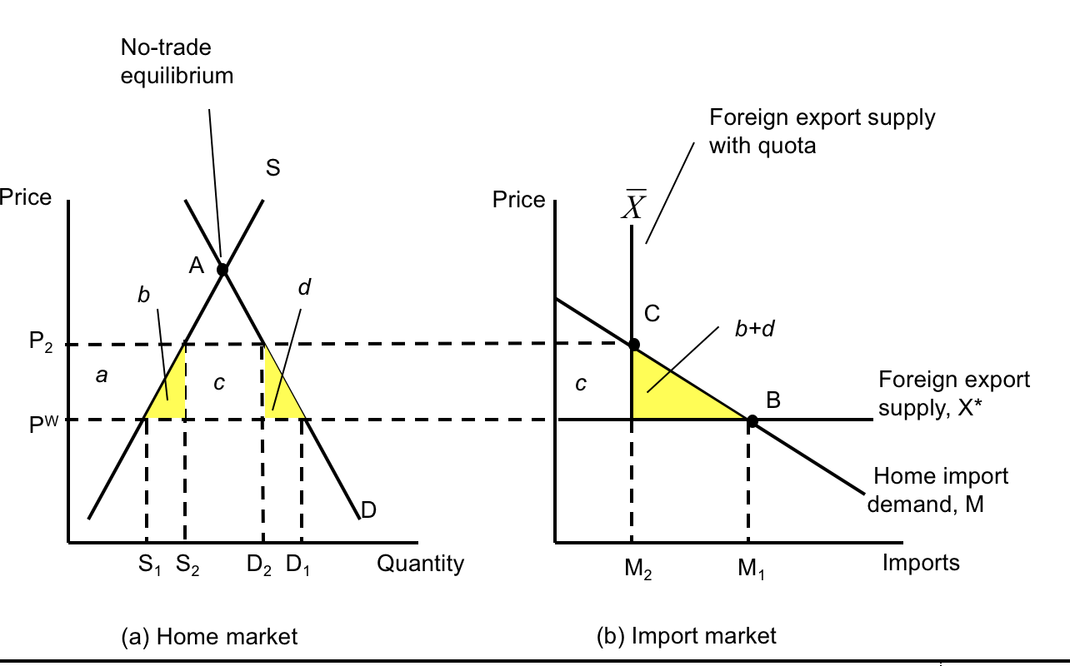

Fig. 1

* 1. Welfare effects when the quota licenses auctioned to Home firms are going to be same as the welfare effects when quota licenses distributed to rent-seeking Home firms.

1. True
2. False
3. Uncertain
4. Don’t have enough information

Answer:

* 1. If Home government decides to impose equivalent tariff instead of quota to reduce import quantity from M1 to M2, the dead weight loss under quota will be:

1. Greater than that under equivalent tariff
2. Less than that under equivalent tariff
3. Same as than that under equivalent tariff
4. Different than that under equivalent tariff, but cannot calculate the difference with the information given

Answer:

* 1. Suppose Home is now a large open economy, the foreign export supply curve will now be:

1. A vertical curve
2. A horizontal curve
3. A negatively sloped line
4. A positively sloped line

Answer:

For answering 1.11,1.12 and 1.13, refer to Fig 2.

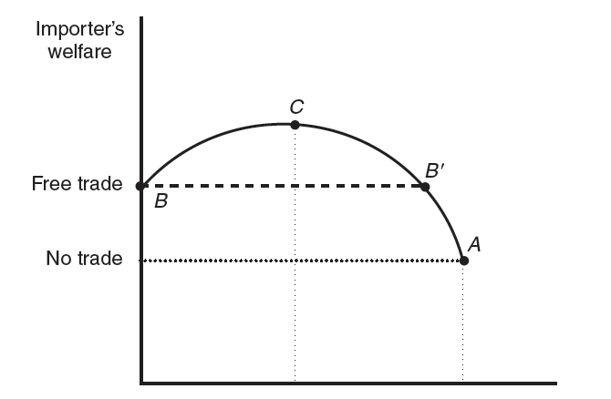

Tariff

Fig. 2

* 1. In Fig 2., the tariff corresponding to point A is known as:

1. Optimal Tariff
2. Prohibitive Tariff
3. Discriminatory Tariff
4. None of the above

Answer:

* 1. In Fig 2., the tariff corresponding to point C is known as:

1. Optimal Tariff
2. Prohibitive Tariff
3. Discriminatory Tariff
4. None of the above

Answer:

* 1. In Fig 2., at point C:

1. TOT gain > Deadweight loss
2. TOT gain = Deadweight loss
3. TOT gain < Deadweight loss
4. None of the above

Answer:

* 1. The sale of discounted milk to Canadian processors under the Commercial Export Milk (CEM) program to assist the dairy industry is an example of:

1. Discriminatory tariff
2. Export Tariff
3. Export Subsidy
4. Export Quota

Answer:

**Based on your project (2 Points)**

* 1. Write down the data source of your project.

Answer:

**Section 2. Short Answers (20 Points)**

* 1. Suppose Spain uses only capital and labor for production of two goods, cars and shoes. There are total 150 workers and 100 units of capital in the economy. Cars use 3 units of capital for each worker, so that Kc = 3 * Lc, whereas shoes use 0.5 unit of capital for each worker, so that Ks = 0.5 * Ls. Suppose there is an inflow of 50 workers in the economy due to immigration, keeping total capital constant at 100. Solve for the amount of L and K used in each industry. (5 Points)

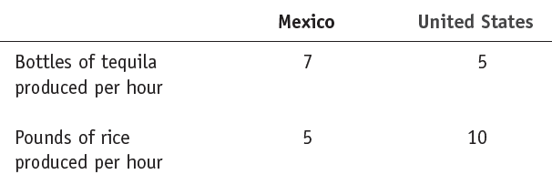

What is the lowest international relative price of tequila that Mexico is willing to accept in order to engage in trade with the United States? Briefly explain why. (5 Points)

* 1. Suppose Boeing and Airbus are deciding whether to invest in R&D to improve the quality of their medium-capacity planes. Given the following payoff matrix in millions of dollars, what is the Nash equilibrium of the game? If the United States government decides to support Boeing with a matching subsidy. Redraw the payoff matrix and find the Nash equilibrium.

(5 Points)

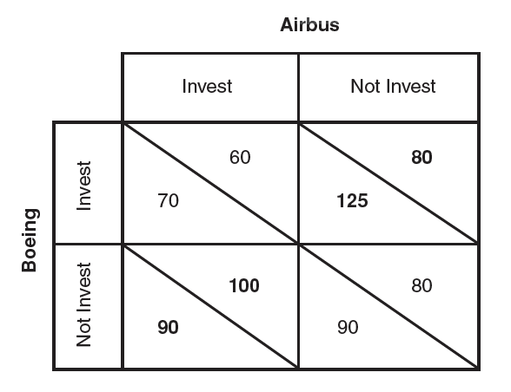

* 1. What are anti-dumping duties? Why do countries use them? (5 Points)

**Section 3. Numerical Problems (30 Points)**

3.1 Suppose the payments to labor and capital in manufacturing and agriculture are given by the following:

**Manufacturing:**

Sales revenue =PM * QM = $150

Payments to labor = W * LM =$100

Payments to capital = RK * K = $50

**Agriculture:**

Sales revenue = PA * QA = $150

Payments to labor = W * LA = $50

Payments to land = RZ *Z = $100

Assumption: The relative price of manufactures, PM / PA, decreases because of a rise in PA, holding PM constant.

Suppose the following price changes:

Manufacturing: Percentage increase in price = ΔPM / PM = 0%

Agriculture: Percentage increase in price = ΔPA / PA = 10%

Percentage increase in the (nominal) wage = ΔW / W = 5%

a. Calculate the Percentage change in Rental on capital (5 Points)

b. Calculate the Percentage change in Rental on land (5 Points)

c. Write down the general equation for the change in factor prices. (5 Points)

3.2 (15 points)

Consider the following hypothetical information pertaining to a country’s imports, consumption, and production of T-shirts following the removal of the MFA (Multi Fibre Arrangement) quota:

|  |  |  |
| --- | --- | --- |
|  | With MFA Quota | Without MFA (Free Trade) |
| World Price ($/shirt) | 2 | 2 |
| Domestic Price ($/shirt) | 2.5 | 2 |
| Domestic Consumption (million shirts/year) | 100 | 125 |
| Domestic Production (million shirts/year) | 75 | 50 |
| Imports (million shirts/year) | 25 | 75 |

1. Graph the effects of the quota removal on domestic consumption and production.
2. Determine the gain in consumer surplus from the removal of the quota.
3. Determine the loss in producer surplus from the removal of the quota.
4. Calculate the quota rents that were earned under the quota.
5. Determine how much the country has gained from the removal of the quota.

**Section 4. Conceptual Questions with Long Answers (20 Points)**

**4.1**

1. Consider that the US is a **large open economy**. Using appropriate graph explain the welfare effects on the consumers, producers and the government of the US economy if the US government imposes an export subsidy of $ s per unit of exports. (5 points)
2. Consider that Mexico is a **small open economy**. Using appropriate graph explain the welfare effects on the consumers, producers and the government of the Mexican economy if the government of Mexico imposes an export subsidy of $ s per unit of exports. (5 points)

OR

1. Consider that the US is a **large open economy**. Using appropriate graph explain the welfare effects on the consumers, producers and the government of the US economy if the US government imposes an import tariff of $ t per unit of imports. (5 points)
2. Consider that Mexico is a **small open economy**. Using appropriate graph explain the welfare effects on the consumers, producers and the government of the Mexican economy if the government of Mexico imposes an import tariff of $ t per unit of imports. (5 points)

4.2

1. State the Heckscher-Ohlin Theorem.

(You don’t need to write the assumptions) (2 points)

1. How did Leontief test this theorem? What did he find? (4 points)
2. Does Leontief’s result hold after adjusting for differences in productivity? If yes, why? If no, why not? Explain using the following graph. (4 points)



OR

1. State the Stolper-Samuelson Theorem. (2 Points)
2. Using the appropriate graph, establish how this theorem holds. (8 Points)

BLANK PAGE